Technical Datasheet Input / Output Modules with MQTT Protocol with Ethernet Interface
The IO Module communicates via an Ethernet Interface and is designed to interface seamlessly with other MQTT-compatible devices. The module acts as an input/output device that bridges the MQTT network and the connected gateway, enabling real-time data exchange over the MQTT protocol. This Digital I/O module is robust, energy-efficient, and user-friendly, making it ideal for a wide range of IoT applications. It supports both digital inputs and digital outputs and allows users to easily publish and subscribe to topics on an MQTT broker, facilitating communication with other devices, cloud platforms, and remote monitoring systems.
4 Port AI Module with MQTT-Ethernet: -
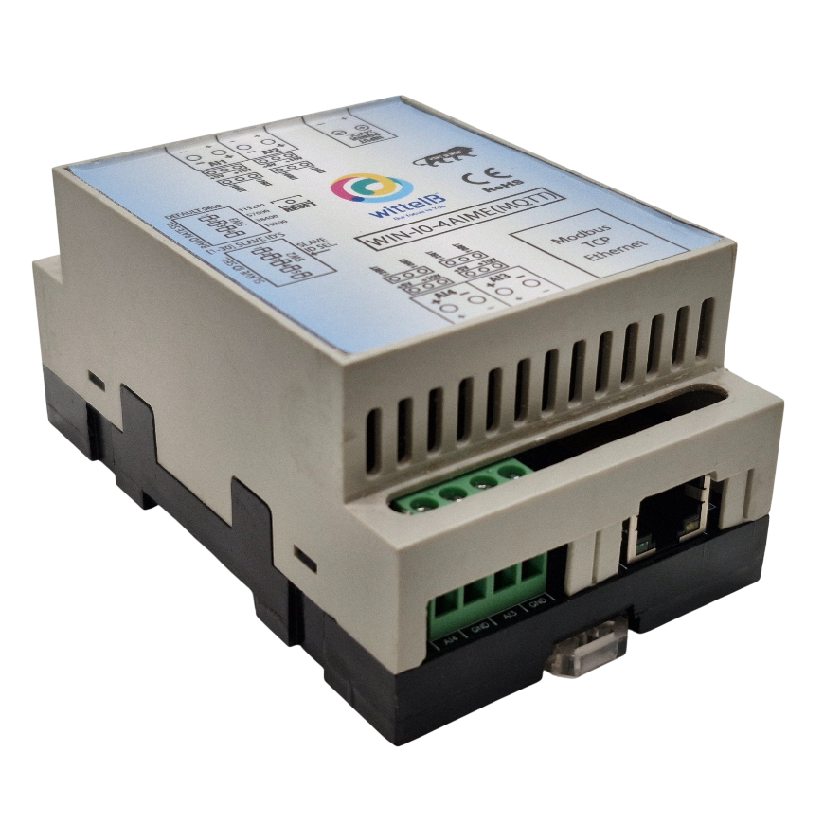
The IO modules are mounted on DIN rail mountable casing and with exposed connectors and LED indicators.
The design of the modules incorporates ‘resettable Fuses’ to safeguard against sudden High Voltage spikes. The board also has ‘reverse polarity’ protection both for input Power connector.
The communication port also has signal isolation and additional Jumper for ‘end of line’ 120 ohms termination resistance which may or may not be used.

Specifications

General:–

I/O Connectors 2 Pin 5.08 mm pitch pluggable screw terminals.
Dimensions 70 mm L x 110 mm B x 50 mm H
Power Input Power – 12-24 VDC
Typical – 12V DC @ 1A
Operating Temperature 0 – 60° C (32 ~ 140°F)
Storage Temperature -20 - 70° C (-4 ~ 158°F)
Storage Humidity 5 ~ 95 % RH, non – Condensing
Certifications 

AI Inputs:–

Channels | 4
Input Signal | 4 – 20 mA / 0 – 10VDC
Accuracy | ± 2% Full scale
Input Resolution | 10 bits / 12 bits (Optional)
Isolation | Optically Isolated
External Loop Voltage | + 12 VDC min
AI input impedance | 120Ω

Technical Specifications:-
- MQTT Protocol Support: Fully compliant with the MQTT protocol, supporting both MQTT 3.1.1 and MQTT 5.0.
- Ethernet Connectivity: Standard Ethernet port (10/100 Mbps) for stable and high-speed data transmission.
- Low Power Consumption: Optimized for low power usage, ideal for battery-operated or energy-efficient applications.
- Easy Integration: Supports standard libraries and tools for easy integration with existing systems.
- Message Retention & Quality of Service (Q o S): Supports various Q o S levels (0, 1, 2) to guarantee message delivery.
- Secure Communication: Support for TLS/SSL encryption for secure communication with MQTT brokers.
- Real-time Data Handling: Efficient, real-time messaging with minimal delay.
- Compact Form Factor: Small and lightweight, designed for embedded systems.
To set up MQTT over Ethernet and find a device's IP address using its MAC address, you'll follow these general steps. This involves setting up an MQTT broker (e.g., Mosquitto, MQTTX, or another broker), connecting devices to the network, and using the MAC address to find the device’s IP. Below is a detailed procedure for setting up MQTT with Ethernet and using a MAC address to find the IP address of a device.

- How To Find the IP Address using MAC Address.

1. Open an IP Scanner Tool
Open an IP scanner tool like Advanced IP Scanner on your device. You can also use any other IP scanner software if you prefer.

2. Scan Your Network
Click the "Scan" button to scan the devices connected to your local network. The scanner will list all devices, showing their IP addresses and MAC addresses.

3. Locate the Device by MAC Address
Look for the device using the MAC Address that was provided with the device. The MAC address will be unique to that device, so it will help you identify it.

4. Find the IP Address
Once you locate the device by its MAC address, you will see the IP Address next to it. This is the IP address assigned to the device on your network.

5. Use the IP Address
Enter this IP address in your any Internet Browser or network configuration to connect to the device.

Note: You can refer to the image provided, where the MAC address and its respective IP address are clearly listed.
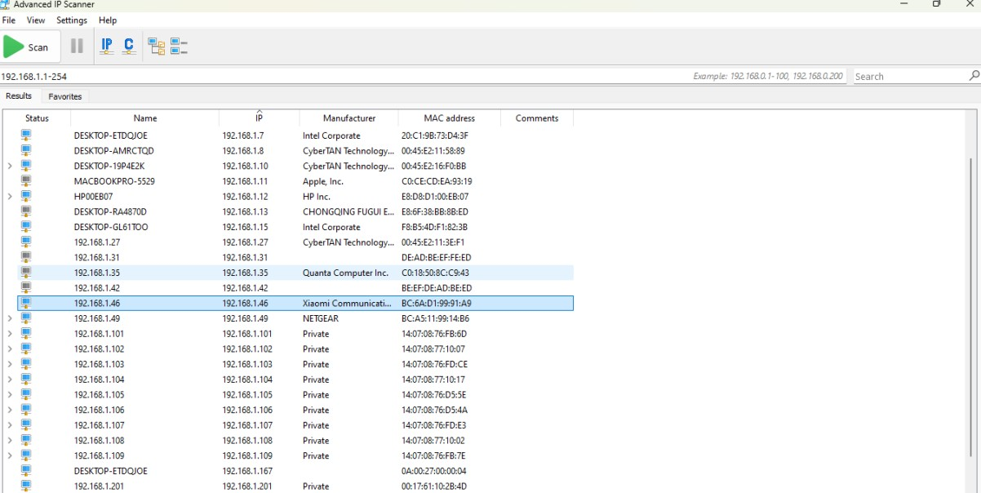

● After Entering the ip You will see interface as shown in the image.

Note: - (For more help you can refer below image1.1 for login)

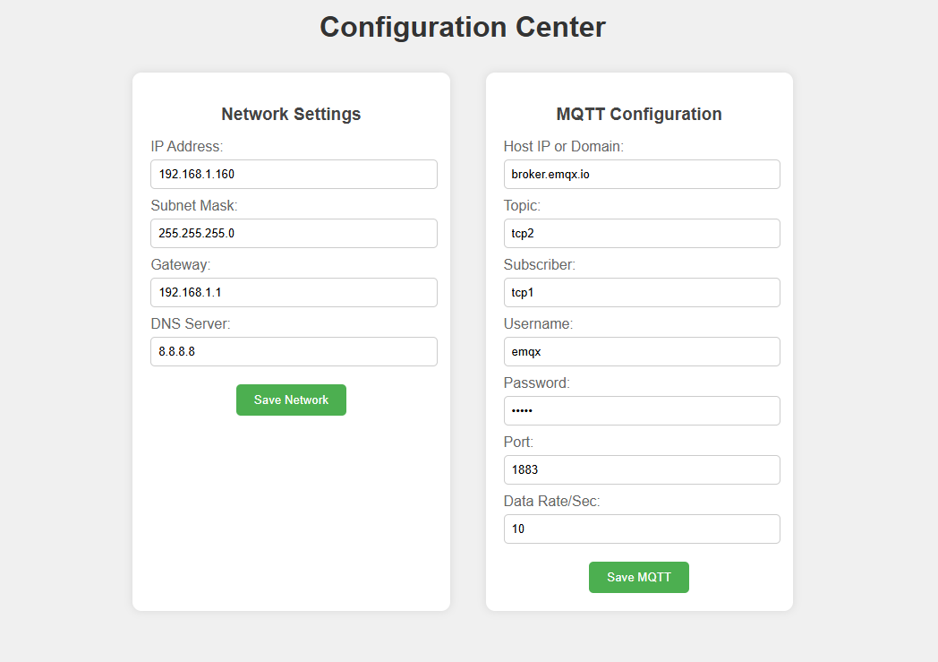
192.168.1.254
Image (1.1)
Configuration Centre

Network Settings:-
- IP Address : (Example:192.168.1.254)
Assign a valid IP Address in your LAN range.

- Subnet Mask: (Example:255.255.255.0)
Usually 255.255.255.0 for most offices and home networks.
- Gateway: (Example: 192.168.1.1)
Enter your routers IP Address.

- DNS Server: (Example: 8.8.8.8)
Google DNS or your local DNS server.

  - Click Save Network to Apply Settings. The device will restart with new network Configuration.
MQTT Configuration:-
- Login Prompt
When you open the device's details page, you will be prompted to enter a username and password.
- Default Username
The default username is usually admin.
- Default Password
The default password is typically admin or password.
- MQTT Port
The default MQTT port is 1883 for unencrypted connections.
For secure MQTT over TLS, use port 8883.
- Topic Name
Ensure you configure the correct topic name where digital i/o data will be published.
For example, if you set the topic to “aitcp”, you will receive analog and digital data on that topic.
- Subscriber:Topic where device will listen for commands to operate relays.
- Data Rate:
The data rate refers to how often the device publishes messages. You can set it to a specific interval, such as every second or every few seconds, depending on how often you want the data to update.
Note: (Username Password is optional).

- Click Save MQTT to store MQTT Settings. The device will attempt to connect to the broker with provided details

- Factory Reset : If you forgot the device IP or Enter the incorrect Network /Mqtt Settings you can restore the device to factory defaults using Reset Jumper.

- Steps to reset:
- Power ON the device
- Place Reset Jumper in Reset Position
- Press RESET button
- Remove jumper
- Power On Device

- Settings will be restored

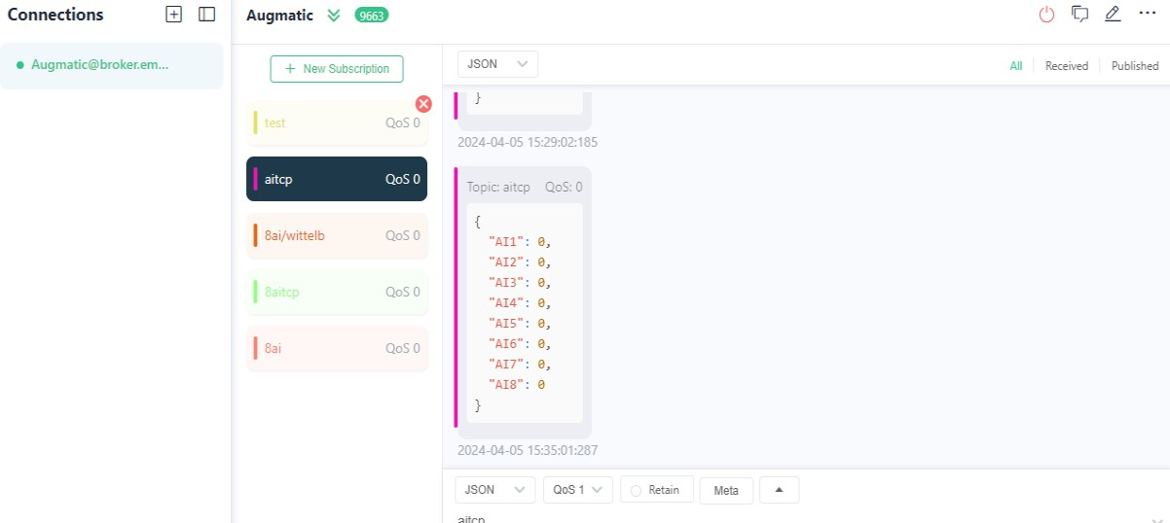

● Here you can see the data of analog input in JSON format, which displays the real-time analog values from all input channels.

Analog Input Data via MQTT:-
To monitor analog input values through an MQTT cloud system, the device publishes real-time analog data to the configured MQTT topic. The data is sent in JSON format, allowing easy integration with dashboards or cloud applications.
Operation Process:
1.Publishing to Topic:
The device publishes analog input data to an MQTT topic (e.g., wittelb_pub) at the configured data rate.
2.Response Format:
When the device sends analog input data, it is formatted as a JSON payload as shown below:
{
"AI0": "1023",
"AI1": "980",
"AI2": "450",
"AI3": "0"
}
  - Each key (AI0, AI1, etc.) represents an analog input channel.
● The corresponding value represents the analog reading (e.g., 0–1023 for a 10-bit ADC or 0–4095 for a 12-bit ADC).
Note:
You can visualize these analog values on your MQTT dashboard, broker console, or cloud platform by subscribing to the same topic where the device publishes data.

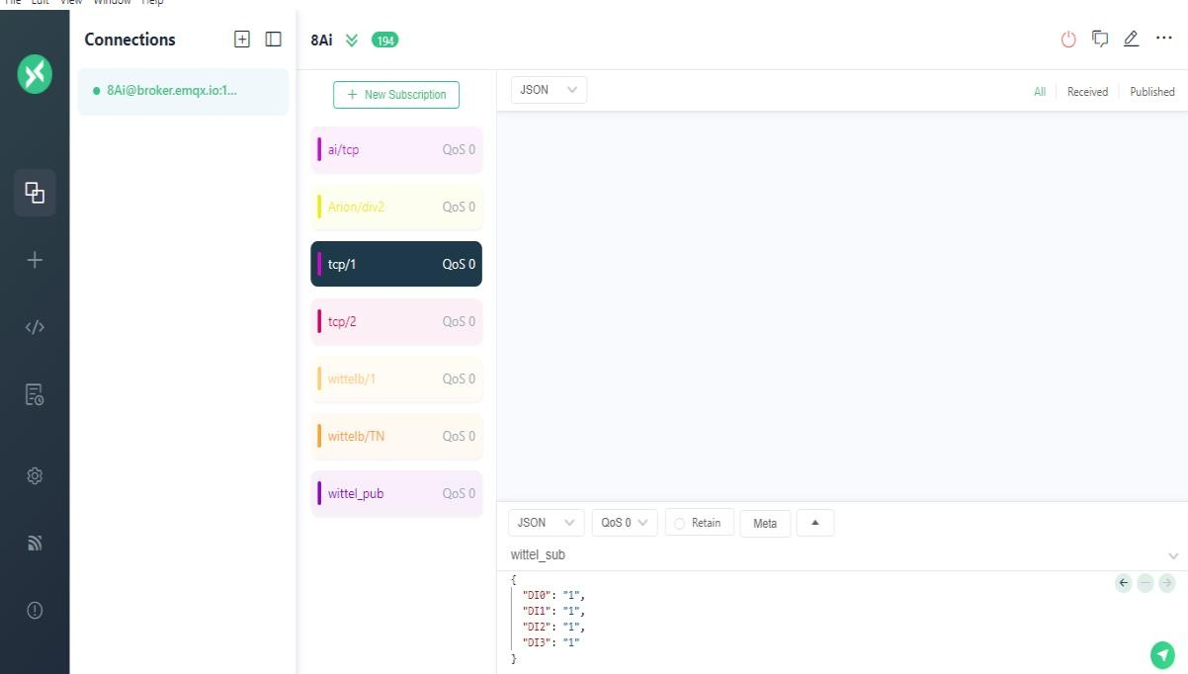

AI
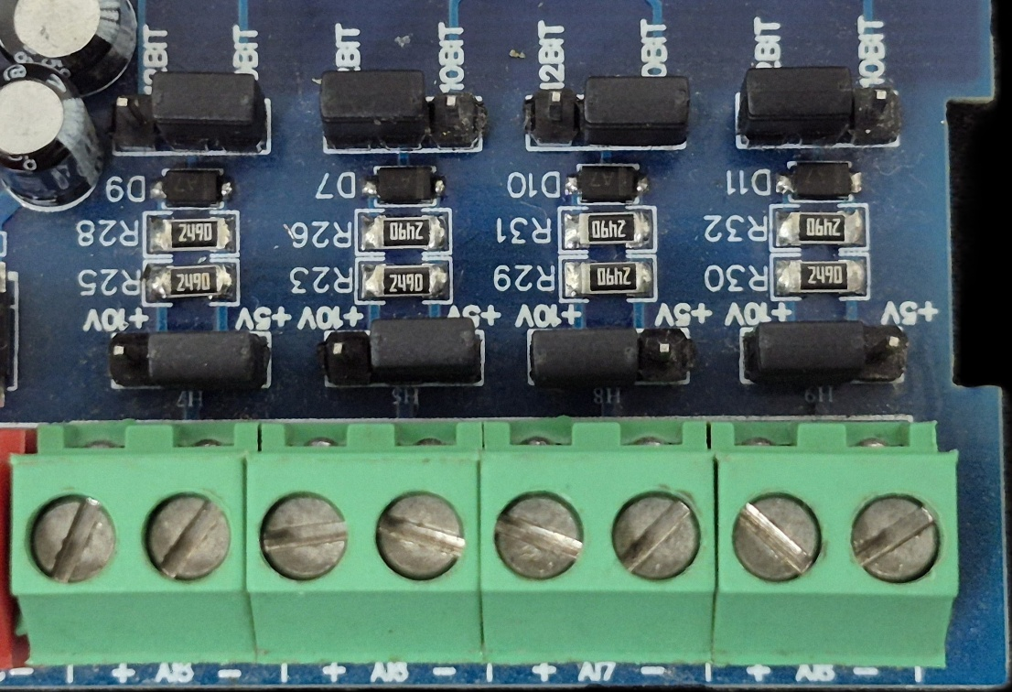
Sensor
Sensor
Sensor
Sensor

- Analog Input (AI) Operation: Each channel provides two terminals: + (Positive) and - (Negative/Common). These are used to read external analog sensor signals.
- Channel Configuration (Visual Guide): Each of the four AI channels features two dedicated jumpers to independently set the voltage range and bit resolution. Refer to the color-coded boxes in the board diagram to configure your desired scenario:
  - Red Box (5V, 10-bit): Set the voltage jumper to +5V and the resolution jumper to 10 BIT.
  - Green Box (5V, 12-bit): Set the voltage jumper to +5V and the resolution jumper to 12 BIT.
  - Blue Box (10V, 10-bit): Set the voltage jumper to +10V and the resolution jumper to 10 BIT.
  - Yellow Box (10V, 12-bit): Set the voltage jumper to +10V and the resolution jumper to 12 BIT.
- Sensor Wiring Connections:
  - The analog sensor's positive signal wire should be connected to the + terminal of the desired channel.
  - The sensor's common or ground wire should be connected to the corresponding - terminal.
- Crucial Setup Recommendation: Always ensure that the voltage jumper setting strictly matches the maximum output range of your connected sensor (either 5V or 10V) to guarantee accurate analog-to-digital conversion and prevent data clipping.

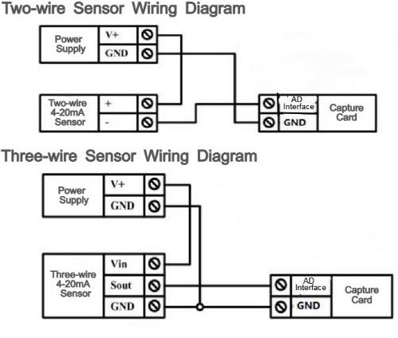

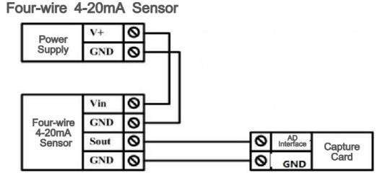

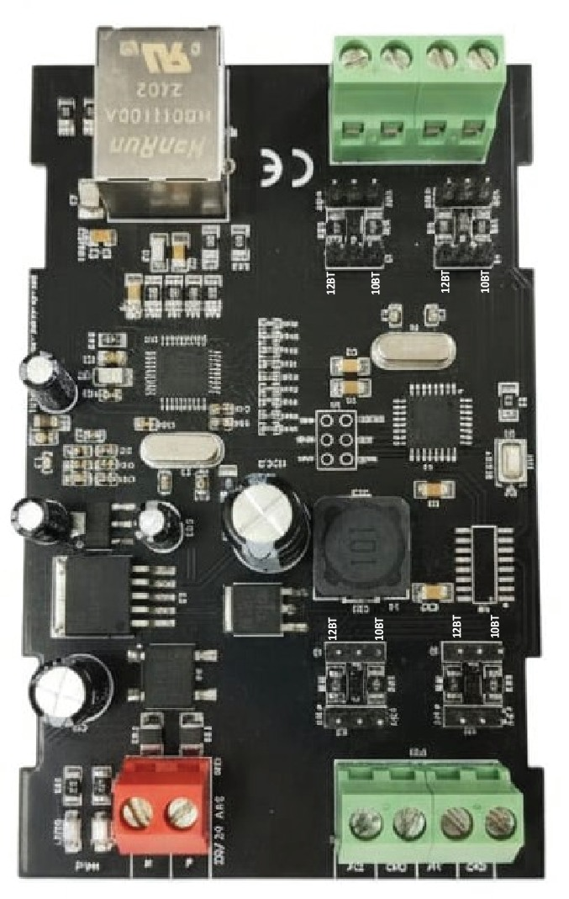

AI Ports

1 2

4 3

AI Ports

Input

12-24
VDC

5V / 10 V

AI Jumper

10
/ 12
Bit

AI Jumper

Modbus
TCP
Ethernet

Contact us: -
Augmatic Technologies Pvt. Ltd.,
Plot no 6, Shah Industrial Estate II,
Kotambi,
Vadodara – 391510.
Email – Sales@wittelb.com
Support: support@wittelb.raiseaticket.com / +91 94038 92805

